# CP3405 SCRUM PILOT STUDY A2

# PROJECT NAME : WHATSNEWS

# Group Members :

Chaoyu Sun 13982618

Yudan Zhang 13812261

Xin Liu 13810926

Kexin Tao 13363330

Aoling Sun 13873354

Qihan Lian 13708078

Junjie Qu 13799450

# 

# **Section - 1 restate the project challenge and analyze pros/cons**

In the days that technology grows at an unprecedented speed, almost every old person has been left behind by society. Though Australia has a high adoption in smartphones, older Australians share the same problems as old people worldwide.

First of all, amnesia is one common problem that happens to most old people, these elderly are having trouble memorizing even the basic things, let alone the complicated mobile functions. As a result, a well functioning smartphone only does basic things like make a call and send messages. What’s worse, they may even cannot find the icon of call and message due to the different design of the icons.

Secondly, when the elderly spend too much time learning and relearning the basic instructions of using the smartphone, they lose confidence and get frustrated. Besides, their self-esteem may be struck by the repetition of learning and forgetting and getting angry with themselves, then label themselves as “not technically minded” people.

Thirdly, the elderly regard technology unreliable, especially when it comes to money-related things. Therefore, they refuse to and fear of using smartphones, rumors like the radiation of smartphones is deadly also exacerbated the situation.

The proposed solution is quite effective in dealing with forgetfulness and the fear of using new technologies. By conducting plenty of investigations and research, the team has figured out how to solve the problem of amnesia in elderly people. Then, they refine or refute existing assumptions by conducting interviews and collecting feedback. I think this is a very effective and desirable method.

In addition, in order to solve the elderly on the new technology fear or loss and other aspects. The team showed patience and enthusiasm during the process. By simplifying the use of applications again and again, the elderly can get the ultimate user experience as much as possible.

However, while this solution is excellent, it does not solve all the problems. Some elderly people think they are not people who learn science and technology, and are unwilling to accept it. Even if the team makes it easier and simpler to use the application, that does not mean they accept it and want to learn it. After setting up the “Appsistant Tutorial”, some people choose to skip the tutorial and go straight to the application. The solution here is still lacking in this perspective.

# **Section - 2 Justify the objectives of the pilot study**

# Throughout the analysis of existing CP2408 proposed solution, elder people are used to old staff, very difficult to move on the new staff, and they are also scared about the new technology which may let them be laughed by someone else. The difficulty part of this project is that are they able to get trust from elder people and believe they are really helping them not harming elder people? However, They focus on how to make technology more suitable for elder people, they did not focus on elder people mindsets and how they really think. Elder people think they may be banned by the society, human is a unique of many social relationships. I think we can put elder people together, let them feel they still got in touch with other elder people, make them feel they are still connected, they are still reliable among others. Once they are active and confident through this process, they are able to learn new technology and get used to the new society with more active and confident attitude. It could be very fast for them to learn it. It could shorten the time which be spent on making product better for elder people. It could be easy for creators to gather more elder volunteers to give experience and improve the product based on elder volunteers’ reflections. Hence, I think if they can spare some attentions on elder people thoughts and their fragile heart, it could make the project better.

# **Section - 3 Summarize Of Weekly Activities**

After we decided on this project, we conducted a series of brainstorming sessions and created our backlog. For the development of each function of the backlog, we have carried out a different division of labor. At the same time, we did a daily standup of our weekly work and reviewed our weekly work. The length of work performed by each person and the velocity of the entire team were counted.

The first thing we need to introduce is our backlog:

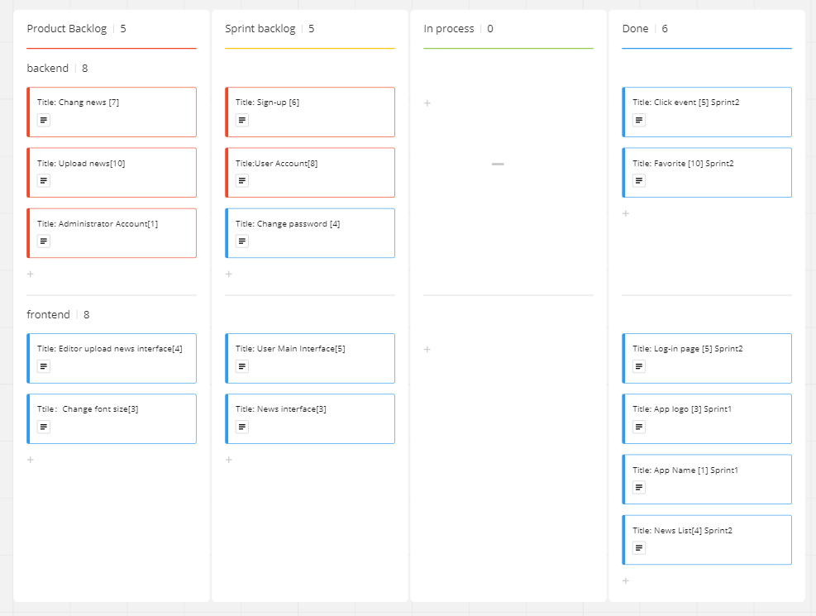

We agree that the backlog is the core of the entire project. It contains all the items needed for the entire project, as well as the items we need to work on in each sprint. Every week, we will take out our projects in the sprint and develop them. At this time, we will put the function(story) under development into the In process section. Then, we will put the developed functions into the Done section. In addition to recording all the functions of the project, the entire backlog also records the development progress of the project.

We will write the functions that we need to do every week, the functions that have been completed, and the problems encountered in the development, in the Daily Standup.

The following is one of the things we do:

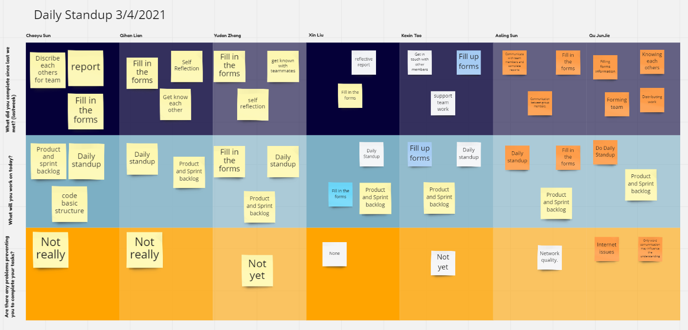

This can help us to better distinguish which functions we have successfully solved, who solved it, and which functions have not been solved, and why. In this case, we can better help each other develop. For example, some team members don't know how to use Android Studio to display the List, but I know so that I can write this function and show the code to him. In this way, while improving the efficiency of the team, the development ability of the team members can be improved.

After we have completed an entire sprint of work, we will review the entire week of work:

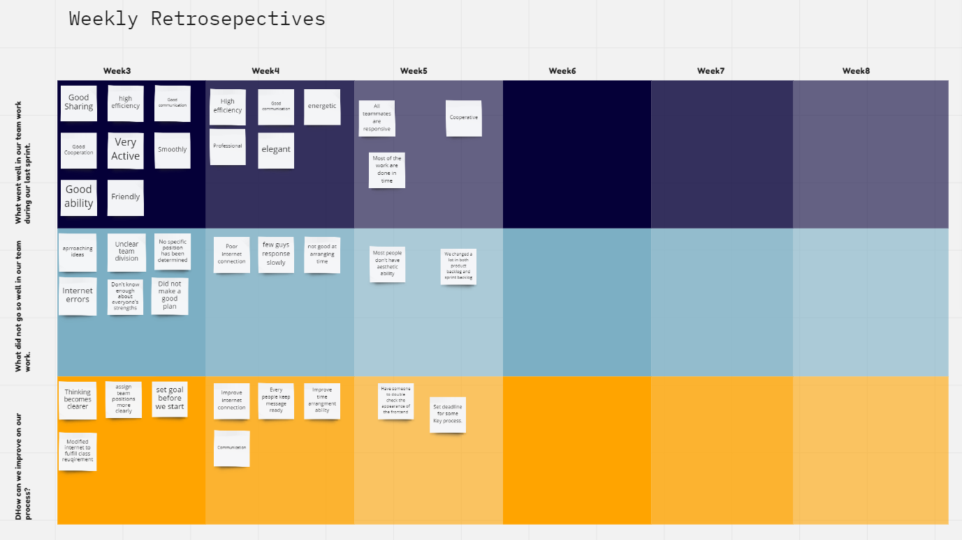

It records what we did well this week, what we did not do well, and what we found to improve the efficiency of the team. The most important point of this module is that it allows us to understand each other better. For example, if a team member is good at the front-end and a team member is good at the back-end, we can write this in the review. After other team members encounter front-end or back-end problems, they can ask questions to both of them. The second is to let us understand the shortcomings of the team, for example, we may not know how to link to the database, then we need to modify the database requirements.

Finally, we counted the length of each person's work. As well as statistics on the velocity generated every week, we can learn the team efficiency of each sprint and the contribution of each member to the team.

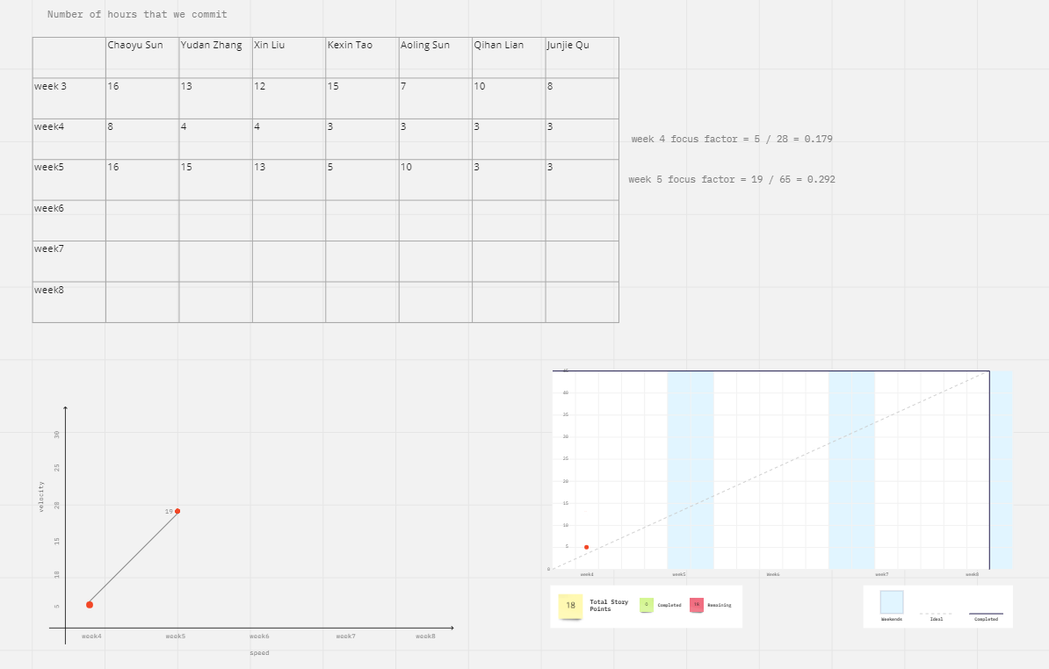

# All in all, although everyone's contribution to the team is different, everyone is working towards a good app. Whether it is the front-end problem or the database problem, in fact, our team members do not have such a good programming foundation, but they have worked hard to overcome them. We are still a very good team.

# **Section - 4 Based on the actual outcome of the pilot study**

1) assess Scrum’s appropriateness as the development methodology for the project work

In general, the Scrum development method is very smooth for the current progress of our team. It is efficient for Scrum and can be applied to a variety of different development schedules. It is suitable for APP development, because APP requirements are often changed. It is suitable for situations where the needs of customers are not clear, because the needs are not very clear, you need to communicate with customers frequently, listen to feedback, and continue to improve. In addition, it is also applicable to a highly competitive market. After all, it is very important to give priority to a competitor to deliver an imperfect but at least usable product.

2) assess the technically feasibility of the project

First of all, our current APP can be market-oriented, and our APP has completed a very basic framework and can implement related functions according to different business requirements. In addition, it is very easy to maintain based on Android Studio. Of course, if compared with some other NEWS apps on the market, our products are slightly inferior, but for our customer groups, most of the functions have been implemented.

3) assess how well your team worked together.

In the whole team, everyone maintains a good level of cooperation.

Everyone has contributed to the team’s maximization in their field of expertise. The progress of the entire project has been carried out in a planned way. Every time everyone can complete our assigned tasks with a relatively fast efficiency. However, the disadvantages Yes: Different people have different technical levels, and some page designs and functions are too simple. We need to check and improve the overall design in every team meeting.In general. Our teamwork level is still very high. In the shortest time, we have completed the highest quality work. If our team can have a more average level, our teamwork level will be better.